Library Management System (LIMS)

1. Introduction
Library Management System (LIMS) is a software system used to manage library activities such as book cataloging, member registration, book issue and return, due-date tracking, and fine calculation.
In manual systems, maintaining book records and transaction history is time-consuming and error-prone. This system automates the process, improves efficiency, and keeps records accurate.
The main focus of this system is transaction logic, especially issuing books, returning books, and calculating fines automatically after the due date.

2. Objectives
- To automate library activities
- To manage books and member information
- To simplify issue and return transactions
- To keep borrowing records properly
- To calculate fines automatically
- To improve service quality and reduce errors

3. Functional Requirements
The system should be able to:
- Register new members
- Allow member login
- Add, update, and remove books
- Search books by title, author, or category
- Issue books to members
- Accept returned books
- Track due dates
- Calculate fine automatically for late return
- Allow librarian to manage transactions
- Generate reports of issued and returned books

4. Non-Functional Requirements
The system should:
- Provide fast response time
- Ensure data security
- Be user-friendly and easy to use
- Maintain data accuracy and consistency
- Support backup and recovery
- Be reliable and scalable

5. Use Case Modeling

Actors
- Member
- Librarian
- Admin

Main Use Cases
- Register Member
- Login
- Search Book
- Borrow Book
- Return Book
- Calculate Fine
- Manage Books
- Manage Members
- Generate Report
- Manage System

Use Case Diagram
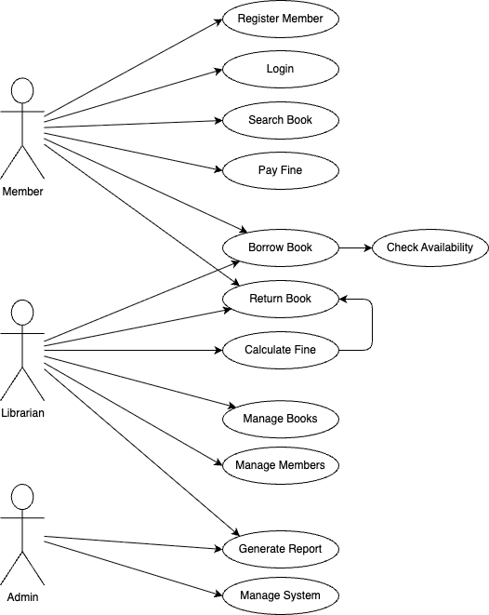

6. Structural Design (Class Diagram)

Main Classes
- User
- Member
- Librarian
- Book
- Transaction
- Fine
- Catalog

Description
- User is the parent class
- Member and Librarian inherit from User
- Member borrows and returns books
- Librarian manages books and transactions
- Transaction stores issue and return details
- Fine stores late return charges
- Catalog helps in searching books

Class Diagram
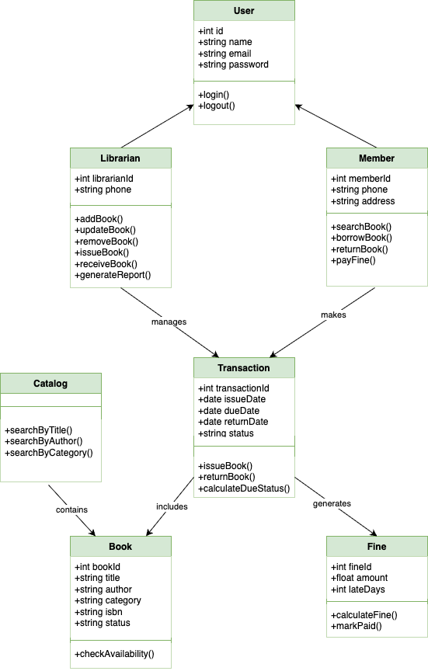

7. Database Design (ER Diagram)

Entities
- Member
- Librarian
- Book
- Transaction
- Fine

Relationships
- Member borrows Book through Transaction
- Librarian manages Transaction
- Transaction may generate Fine
- Book belongs to library catalog

Suggested Primary Keys and Foreign Keys
- member_id as PK in MEMBER
- librarian_id as PK in LIBRARIAN
- book_id as PK in BOOK
- transaction_id as PK in TRANSACTION
- fine_id as PK in FINE
- MEMBER, LIBRARIAN, and BOOK referenced in TRANSACTION
- TRANSACTION referenced in FINE

ER Diagram
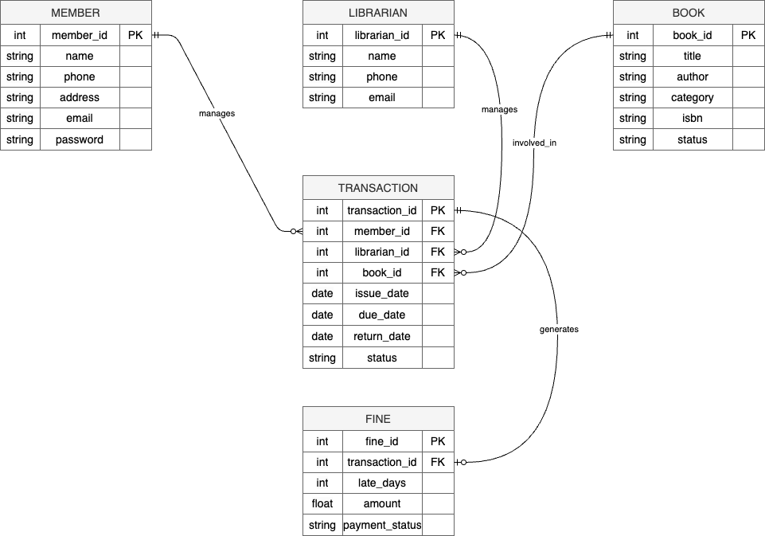

8. Advantages
- Reduces manual work
- Saves time
- Improves record accuracy
- Makes book tracking easier
- Supports automatic fine calculation
- Improves member service

9. Limitations
- Requires technical knowledge
- System failure may affect library work
- Initial setup cost may be high

10. Conclusion
The Library Management System is an effective solution for managing library activities digitally. It simplifies book transactions, improves record management, reduces manual errors, and ensures automatic fine calculation for overdue returns. This makes the library service more efficient and organized.

